**Contents**

Introduction……………………………………………………………………….

Team Members………………………………………………………………….

Roles………………………………………………………………………………….

Gantt Chart…………………………………………………………………………

Main Work Screenshots…………………………………………………….

Conclusion………………………………………………………………………….

## 

## **INTRODUCTION**

With the help of agile mythology, we create an android application on Fruit Pedia which is an encyclopaedia of Fruit details manage by admin. In this app, there are two user one is admin and another is registered user. Admin is capable to maintain the all-fruit information reside inside application. Registered user capable to access all fruit information as their requirement.

# **TEAM MEMBERS**

**1. First**

**2. Second**

**3. Third**

## **ROLES**

**First**: Product Owner

**Second**: Scrum Master and Stakeholder

**Third**: Developer

## **GANTT CHART**

## **Main Work** **SCREENSHOT**

Fruit Type Table Screen Shot

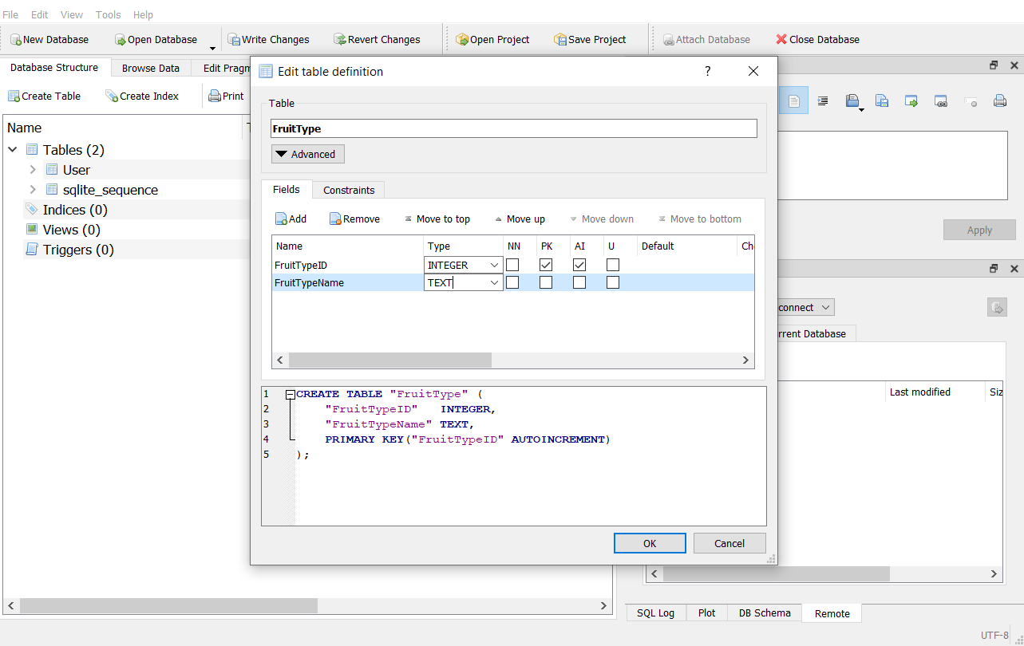

User Table Screen Shot

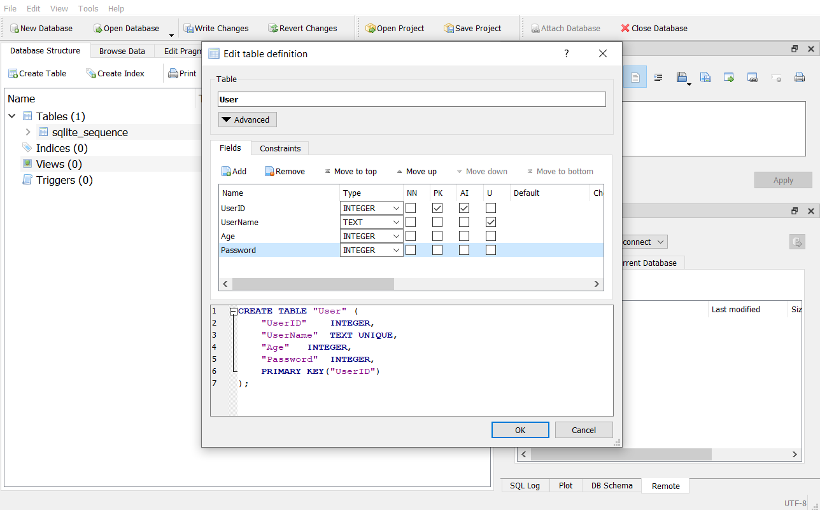

Fruit Table Screen Shot

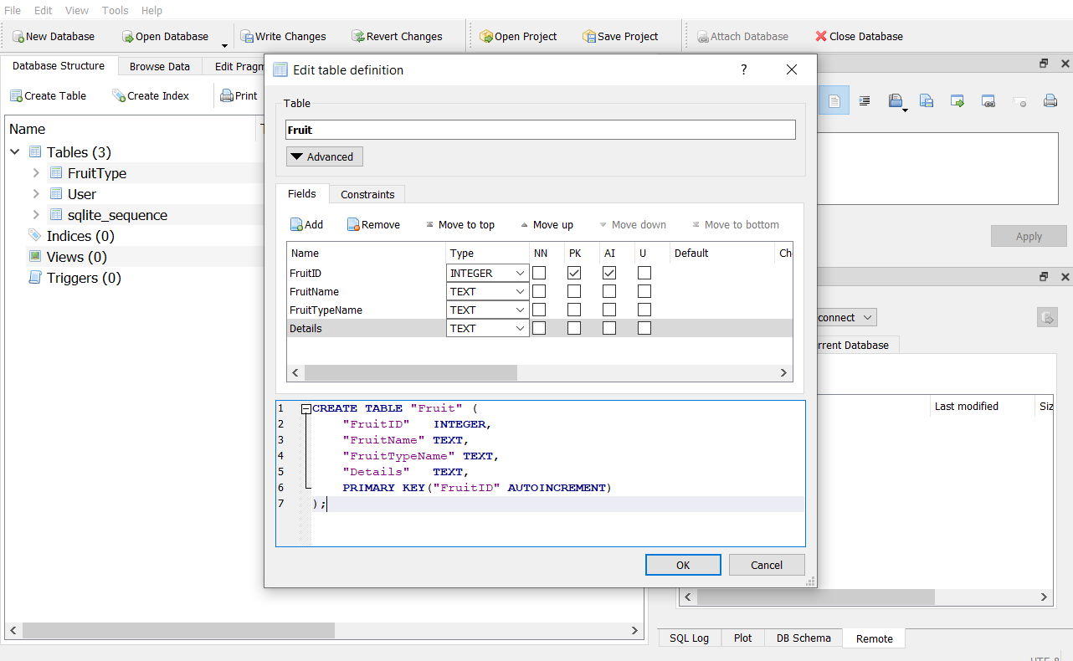

Splash Screen:



Admin Home Operations Screen:

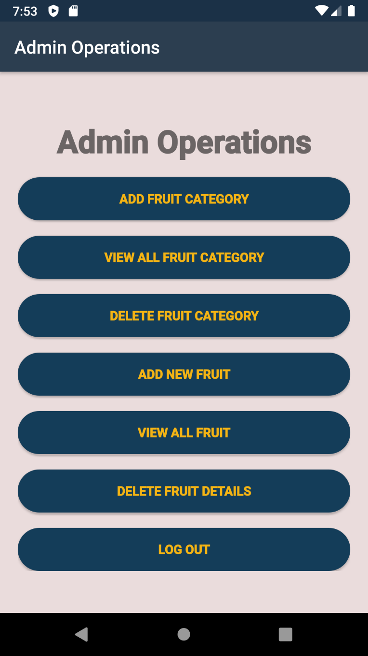

Add Fruit Category Screen:

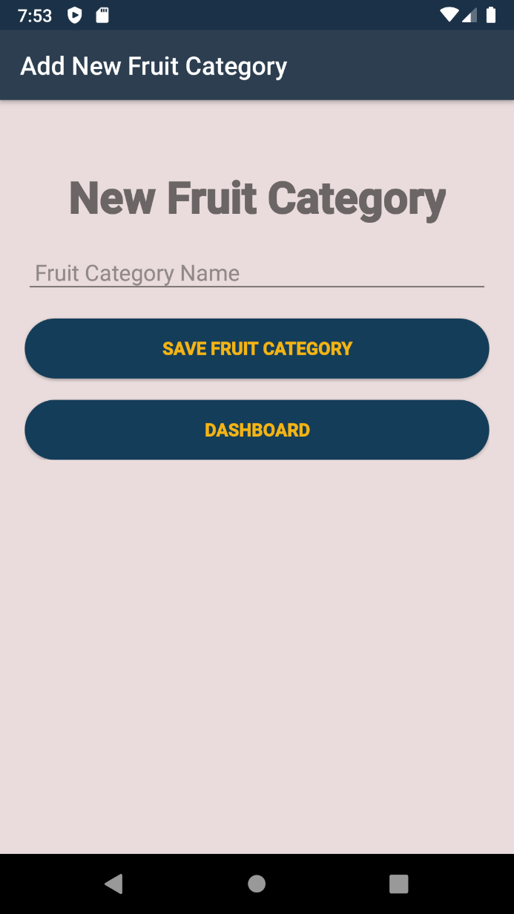

Delete Fruit Category Screen:

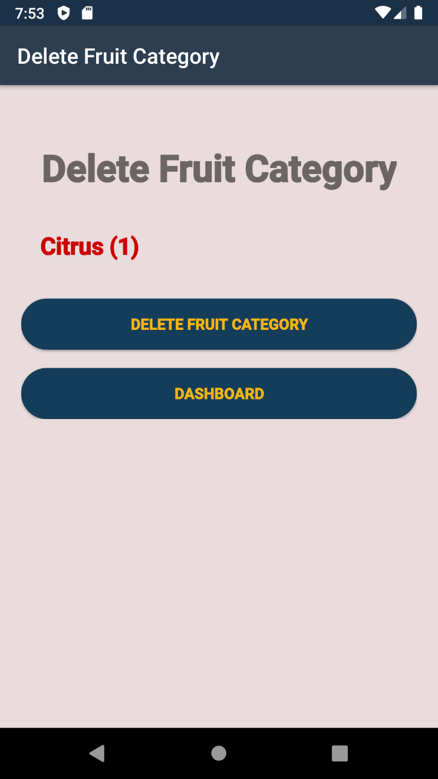

View All Fruit Category:

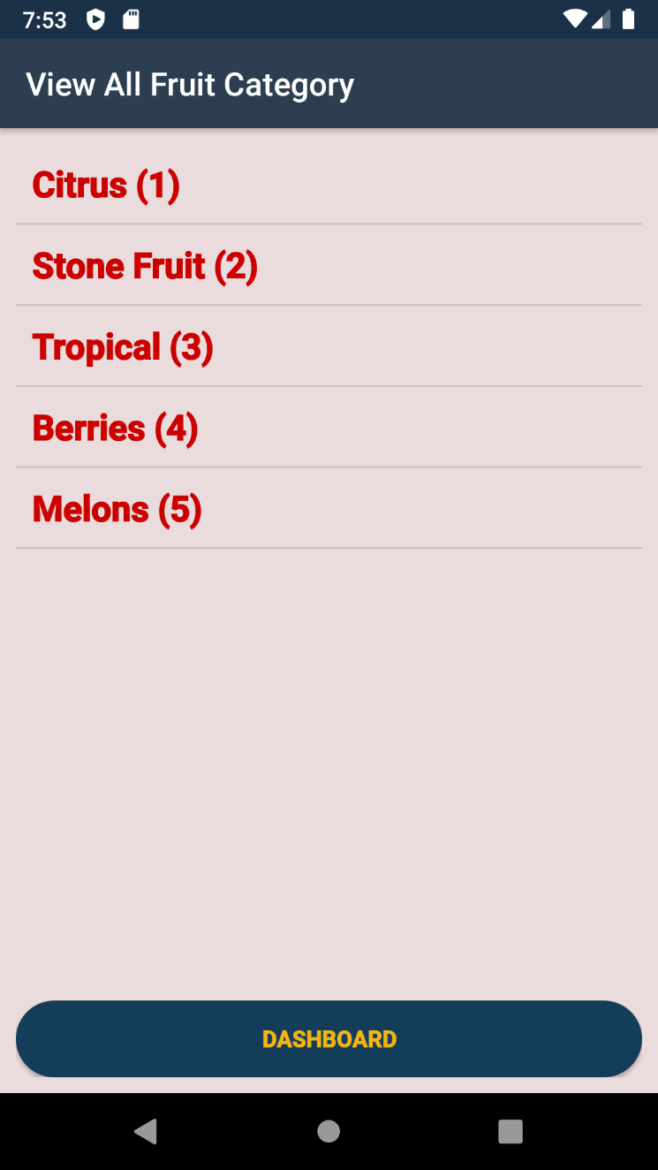

Add Fruit Screen:

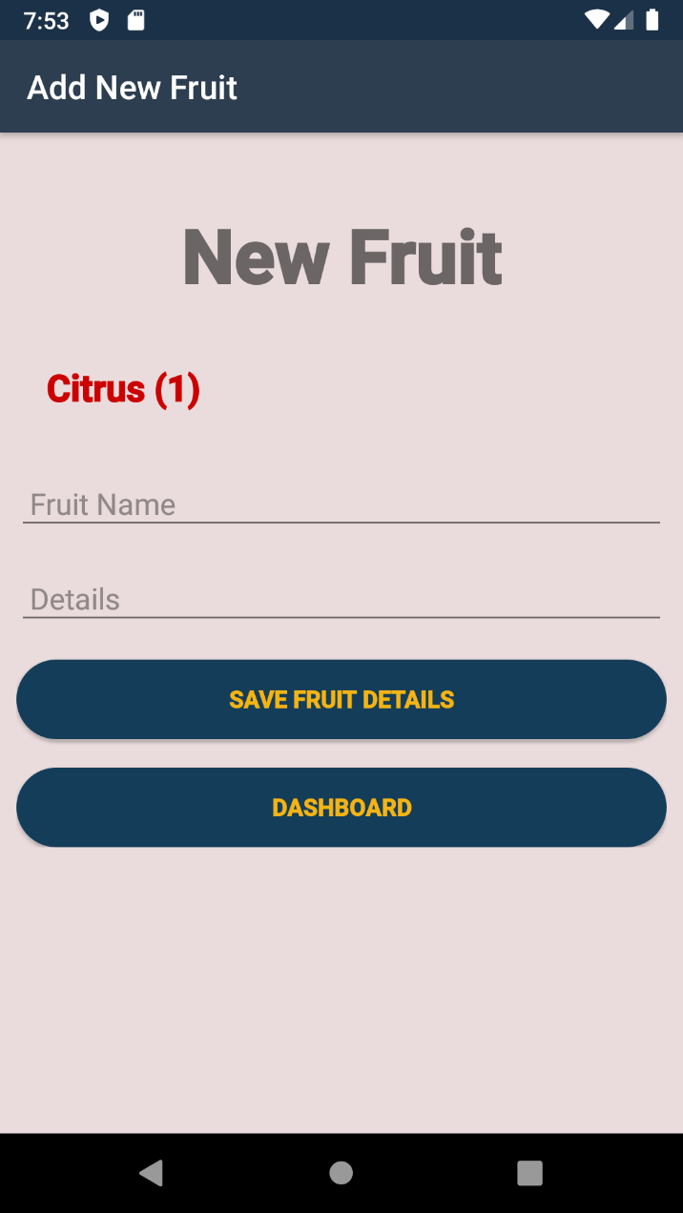

## **Conclusion**

Agile and scrum methodology are used by the project managers for keeping the track of work. As it quickly reacts to changes and is more flexible as compared to others.

To sum up, this application is for the user to register their details and search the fruit details according to their fruit category. Admin panel provide an environment to control the app data. If this application get chance to interact in market this will be suitable for the target audience and fulfil its main purpose.